TABLE OF CONTENTS

**I.** **Installing EZ Learning 2.0** 2

**II.** **Signing Up an Account** 3

**III.** **Logging In Your Account** 4

**IV.** **Changing Appearance Mode** 5

**V.** **Accessing Note Folders** 5

**VI.** **Accessing Note Files** 5

**VII.** **Editing Notes** 5

**VIII.** **Downloading Notes as PDF** 5

**IX.** **Sharing Note Files** 5

**X.** **Accessing Quiz Folders** 5

**XI.** **Accessing Quiz Files** 5

**XII.** **Editing Quiz** 5

**XIII.** **Play Quiz** 5

**XIV.** **Show Score Table** 5

**XV.** **Sharing Quiz Files** 5

**XVI.** **Access Received Shared Files** 5

**XVII.** **Recycle Bin** 5

**XVIII.** **Profile Settings** 5

**XIX.** **Logging Out Your Account** 5

**XX.** **Contacting Developers** 5

# **Installing EZ Learning 2.0**

EZ Learning 2.0 is currently only available as a working prototype, which means that the application is still under development.

Once completed, there will be an exe file that you can install to use the application.

For the mean time, you can access the application by cloning the Git Main Repository in your computer or by downloading the ZIP file of the application. Access the link at:  
<https://github.com/Magnum-Opus-App-Dev/EZ-Learning-2.0>

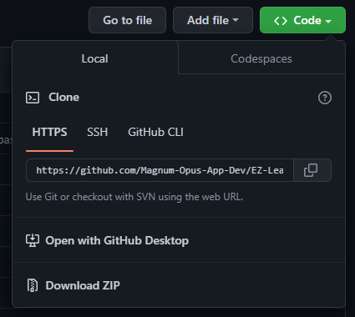

You will be able to run the application by opening the EZLearning2.0.py inside the folder that you have downloaded.

# **Signing Up an Account**

Once you have opened the application, you will be asked to log in you account. If you do not have your own account, click Create New Account Button:



When creating your own personal account, you will be asked to enter your Username, Email, Password, and to confirm your Password.

These steps are necessary as the email and password you have set will be used to whenever you are logging in your account.

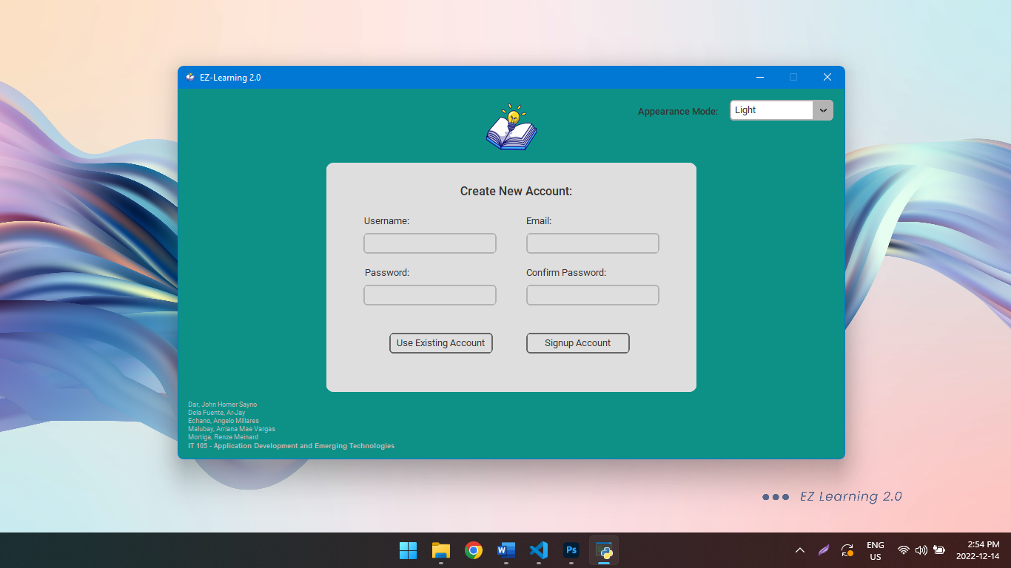

Once the required fields are filled, click Signup Account.



You may now use your account in EZ Learning 2.0.

# **Logging In Your Account**

When logging in, all you have to do is to indicate your email and password.

Once you have meet the required fields, click the login button and you will be redirected to the Notes Folder of the application.

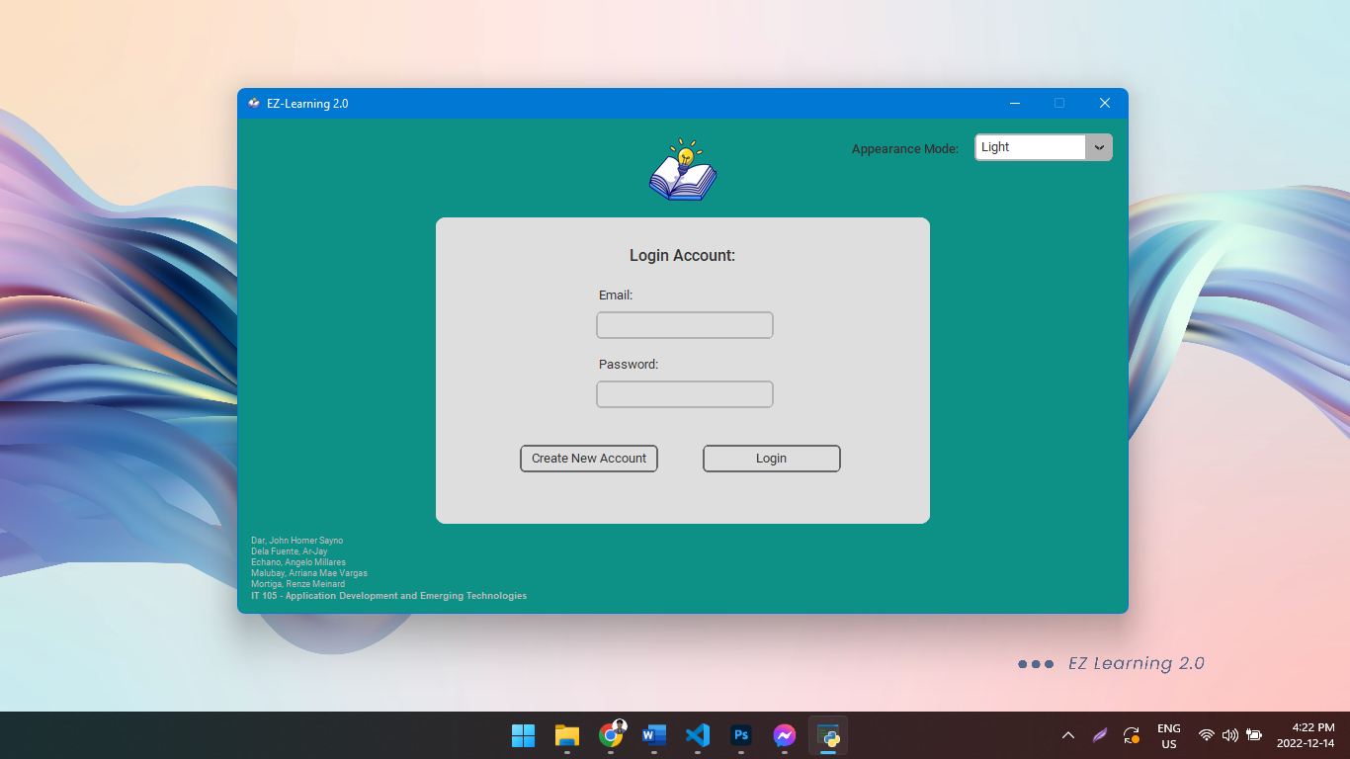

Don’t have an account? Click here.

# **Changing Appearance Mode**

You can change the appearance mode of your application from light to dark mode and vice versa. By default, the system is in light mode. You can change it by click the Appearance Mode Combo Box.

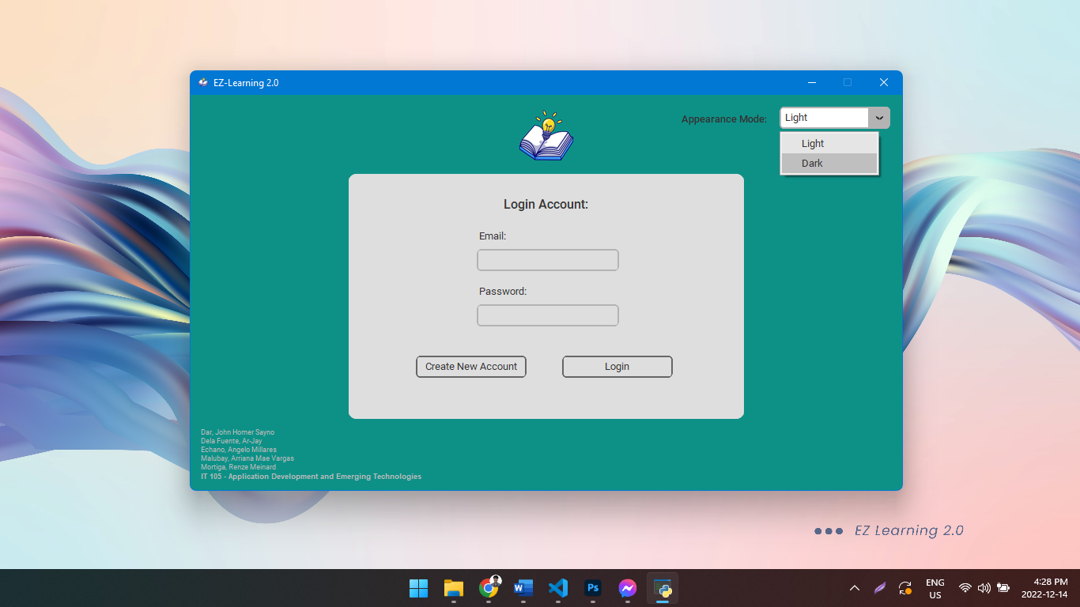

You can change the appearance mode of your application on the sign up and login feature.

# **Accessing Note Folders**

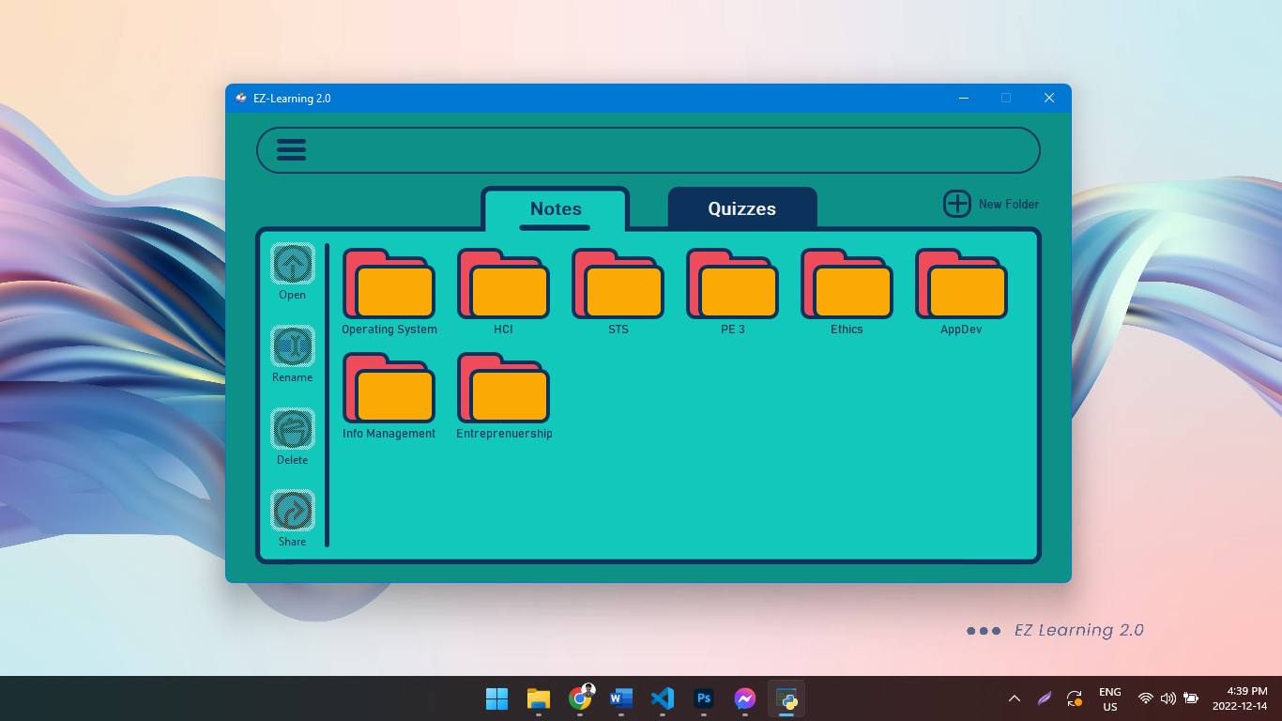

You can create folders based on your choices, e.g., by subjects, etc. Create a new folder by clicking New Folder.



Once clicked, you will be asked to enter your chosen name for the folder:

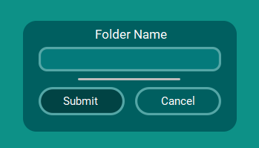

Click save if you want to continue creating the folder, click cancel if you don’t.

You can open a folder by clicking your chosen folder, then clicking the open button.

The open button is inaccessible unless you have clicked the folder you want to open.

Comparison of the Open button:



The same idea is applied to the other side buttons (excluding the back button found in the other features.)

You can also rename, delete, and share folders:



# **Accessing Note Files**

To access individual note files, you need to open a specific folder.

Do not know how to open a folder, click here.

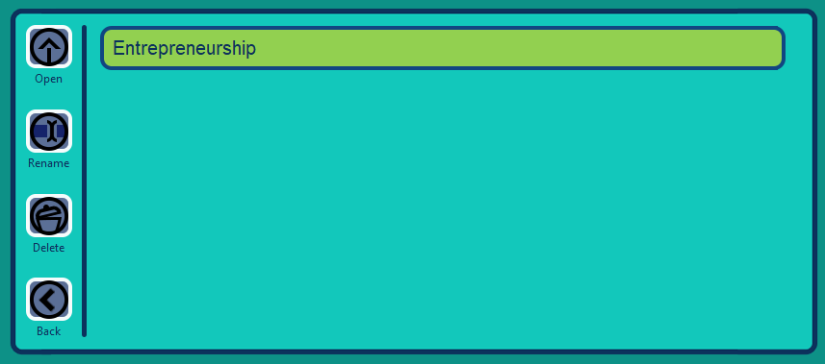

Once a folder is open, you can access its individual note files.

You can create new notes by clicking New Notes.

You can also open, rename, and delete these files by clicking the file, then the button of your chosen action.

To go back to the Note Folders feature, click the back button.

# **Editing Notes**

From the Note Files, click the file you want to edit, then click open.

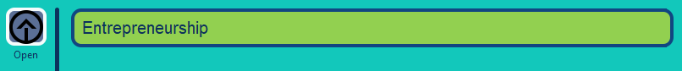

Once clicked, you will be redirected to the editing feature of your notes.

You can edit your notes however you want.

In here, you can save and export to PDF your notes.

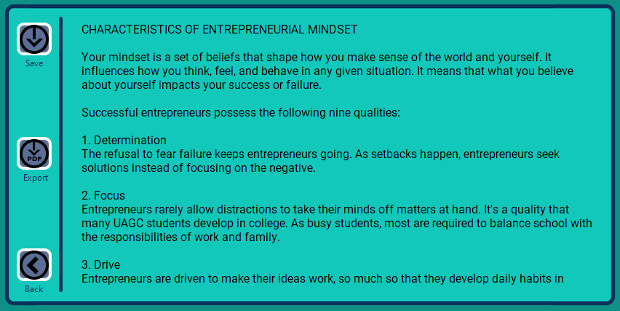

You can also click the back button to go back to the note files.

# **Downloading Notes as PDF**

To export your notes into pdf, you have to be in the note file you want to export, to be there, click here.

Click the export button to begin the process.

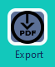

Once you have clicked that, you will be asked to enter the name of the PDF file you want to export.

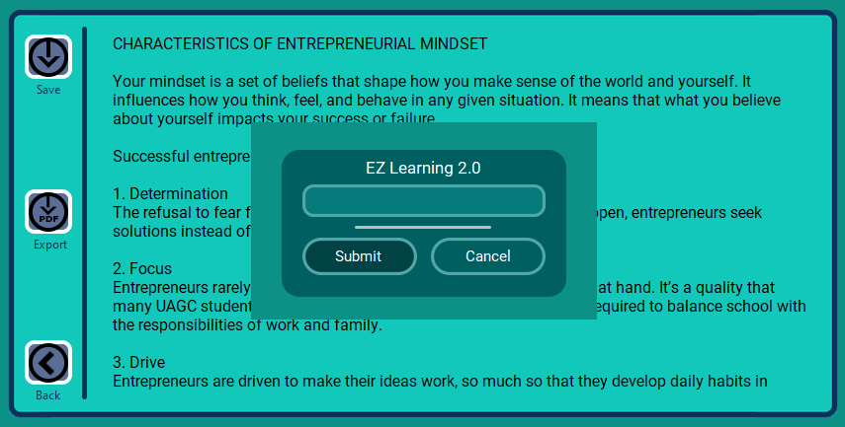

Enter your chosen file name and click submit.

After this, you will be asked where you want to save that note. Choose a folder or directory you want.

Click Select Folder and your PDF file will automatically be saved there.

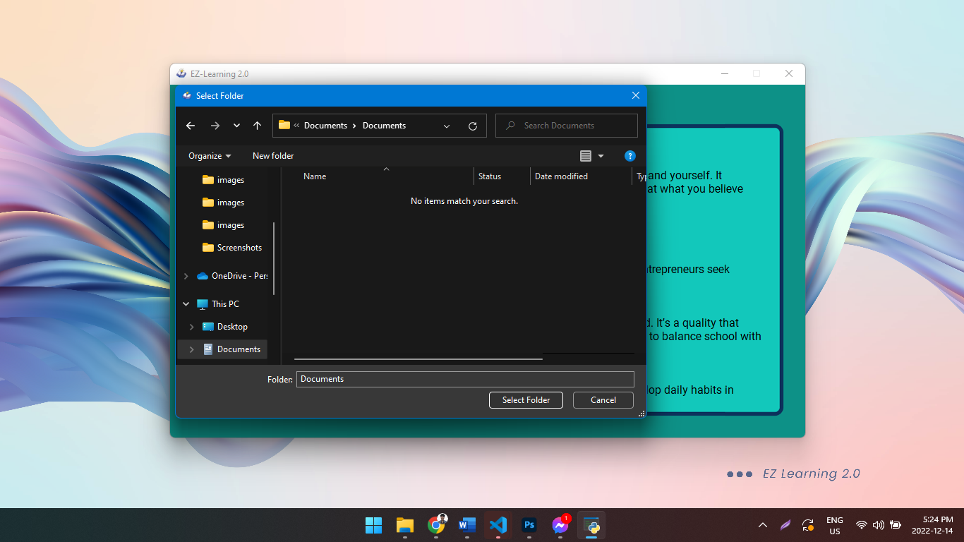

This is what the file will look like:

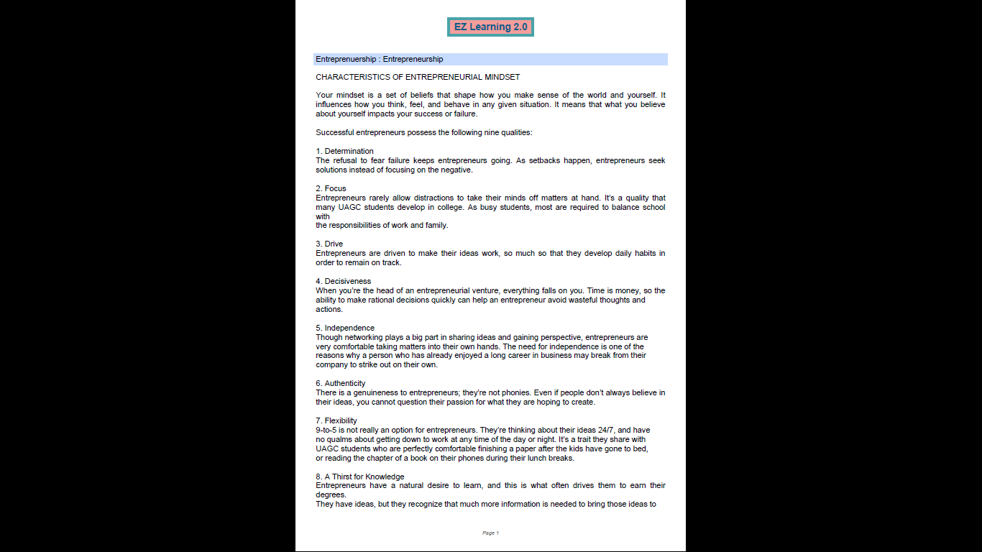

# **Sharing Note Files**

Want to share a folder to other users? Click Share and then type the email of the user you want to share the file.

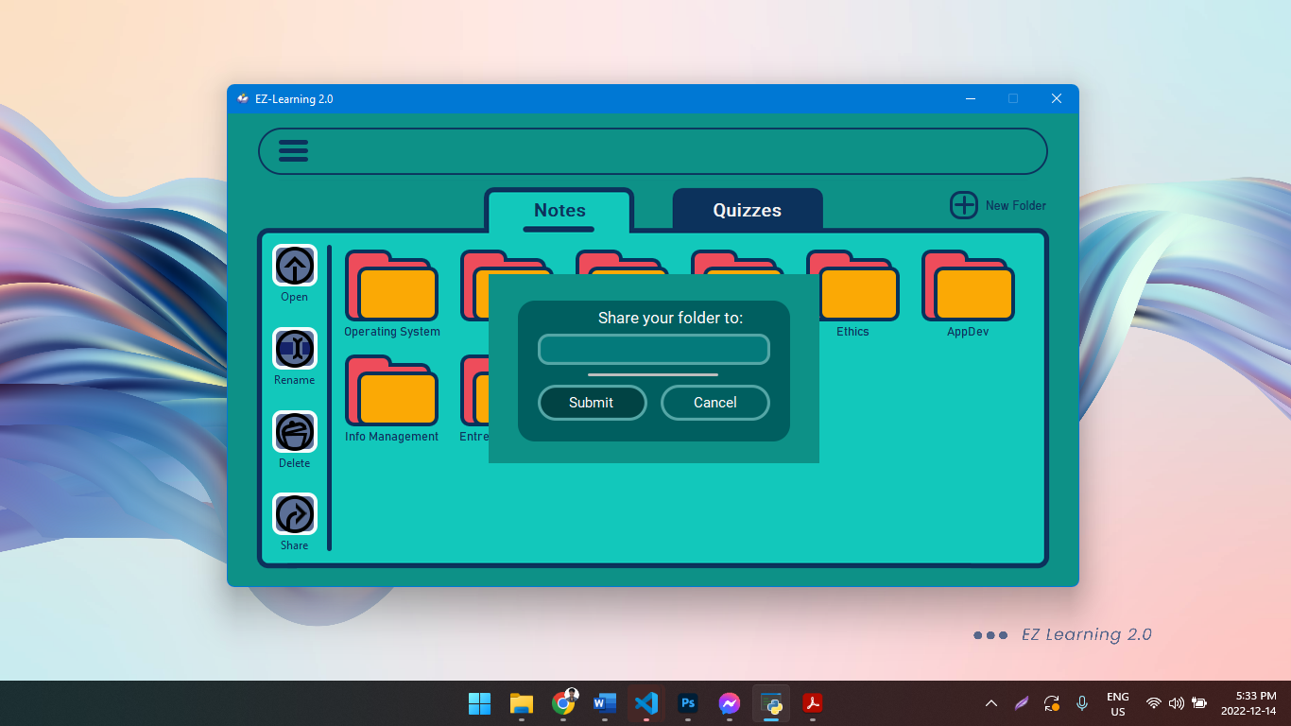

Click submit to share the folder to others.

# **Accessing Quiz Folders**

Click the quizzes button besides the notes dashboard to see your quiz files.

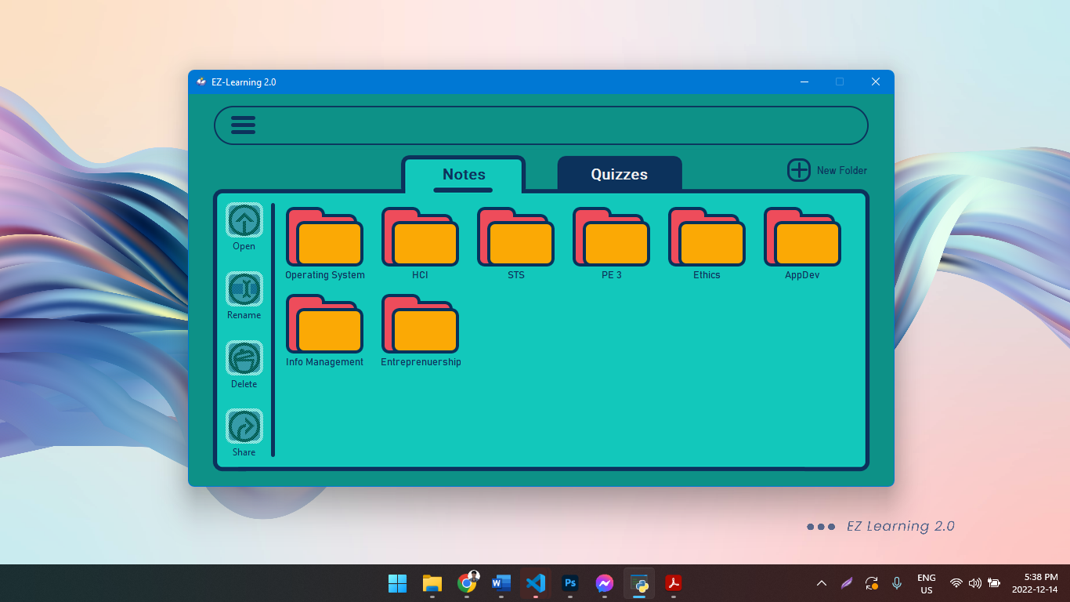

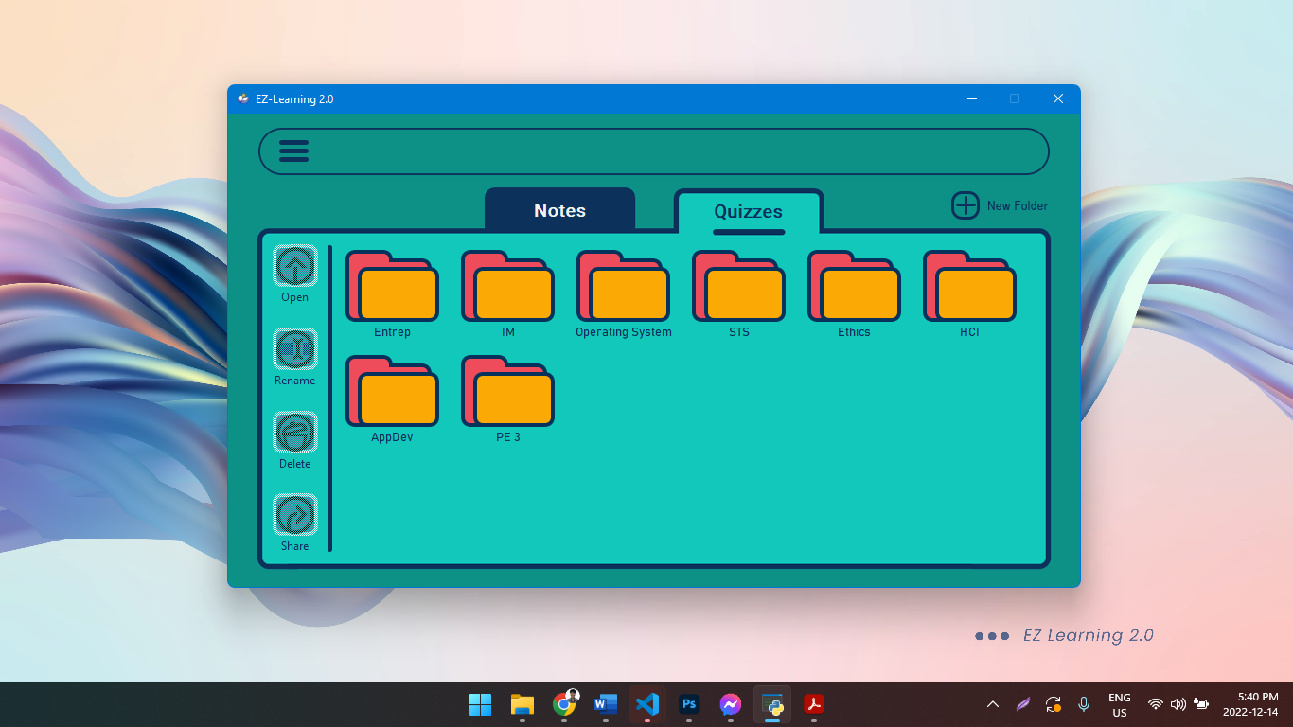

The same rules from notes are applied to quizzes. Click here if you have queries.

# **Accessing Quiz Files**

To access the file, click the folder first and then choose the “open” button on the left side.

# **Editing Quiz**

In editing the quiz, click the file again and choose the “open” button on the left side. Then, you will be redirected to the Quiz Editor.

# **Play Quiz**

To play the quiz, you may navigate the buttons on the left side. After answering all the questions, click the submit button on the top of the file.

# **Show Score Table**

In editing the quiz, click the file again and choose the “open” button on the left side. Then, you will be redirected to the Quiz Editor.

# **Sharing Quiz Files**

# **Access Received Shared Files**

# **Profile Settings**

# **Logging Out Your Account**

# **Contacting Developers**